Site Specific

Temporary Installation

Proposal

2018-2019

**Seeking space in the world in to build new installations.**

Beginning with a sequence of intricate processes a material is crafted to cut and sew together. These images come from past works that represent the spirit in which new ones will be created.

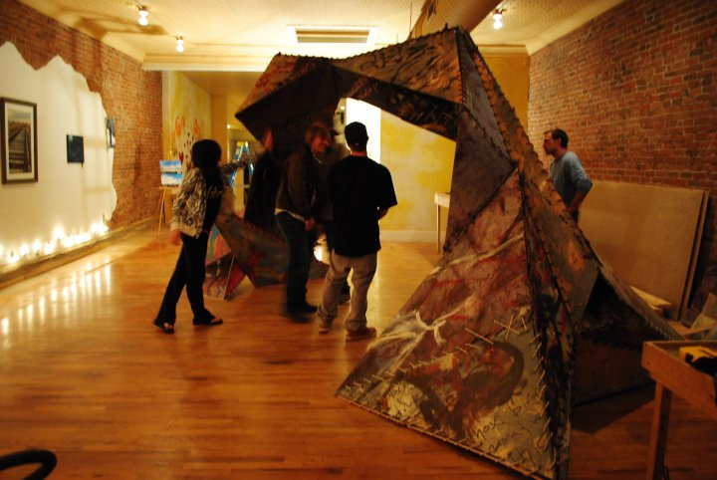

If you, or someone you know, has an artistically themed event that might accommodate original temporary environment art I’d love to connect.

Very Best,

Jarvis Fosdick

970-290-7893

[Jarvis@fastmail.fm](mailto:Jarvis@fastmail.fm)

IG: @jarvisfosidck